Has the Rover Renewed Interest in Engineering?
[edited from an article by Ania Monaco in the IEEE Roundup newsletter, August 22, 2012, with embedded web links (in color). IEEE is the Institute of Electrical and Electronic Engineers. ]
“More than 3 million people watched the dramatic landing of the Curiosity rover on Mars, live online, on 6 August at approximately 1:30 a.m. EDT, and more than 1 million others tuned in to various cable networks’ coverage.
It was an incredible moment. And it was especially moving to see NASA’s Jet Propulsion Laboratory engineers rejoice when it was confirmed Curiosity had survived its “seven minutes of terror,” landing perfectly on the Martian surface following a technically mind-boggling process: http://www.youtube.com/watch?v=Ki_Af_o9Q9s. This video explains why the landing sequence and hardware was designed the way it was. So many things could have gone wrong, but didn’t.

I couldn’t help but get a little choked up watching the JPL engineers leaping out of their seats, hugging each other, some even crying. What must have been going through their heads? They were realizing that the result of their many years of hard work had just landed on another planet millions of miles away and was now communicating back.
Although those of us watching from home hadn’t worked on the mission, we still felt some of that relief, happiness, and pride. And you could see that interest among much of the public, who seemed mesmerized by the Mars rover. Curiosity wasn’t the only overnight sensation. During the nail-biting wait for the rover’s fate, viewers watched the mission control engineers, their faces serious and focused on the enormous task at hand.

Amid the crowd, one face — (page down to continue)

or should I say hairstyle — stood out:

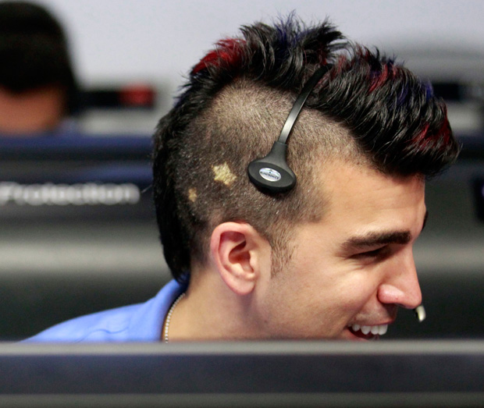

And boy did the Internet take notice. Flight Director Bobak Ferdowsi, sporting a red-tinted mohawk with bleached stars on the side, became an instant Internet star. Twitter was buzzing with one question: Who was this NASA mohawk guy? A slew of meme photos featuring Ferdowsi were created, his Twitter account went from a few hundred to more than 50 000 followers in a matter of days, and he even began receiving marriage proposals from strangers—a telltale sign of fame.

Someone even created a video featuring people impersonating hip JPL engineers singing “We’re NASA and We Know It,” a spoof of the popular song “I’m Sexy and I Know It” by LMFAO. [ http://www.space.com/17136-curiosity-team-spoofed-in-hilarious-viral-video.html ]

Over the next few days, Ferdowsi was interviewed by dozens of reporters, explaining that he sports a different hairstyle for each mission. In one interview, he seemed humbled by the instant fame, but added that he hoped his nontraditional hairstyle would help change the public’s perception of the stereotypical engineer.
“If my mohawk gets a few more people excited about science and this mission, then that’s awesome,” he said. “I hope [the excitement around the mission] encourages a lot of people to get into math, science, technology, and engineering. It’s a lot of fun, and you don’t have to look like the guys in the skinny ties and white shirts and glasses.”
Ferdowsi’s comments reminded me of IEEE Fellow Karen Panetta’s work on the Nerd Girls program, which is aimed at dispelling negative stereotypes about technical fields and the women who work in them. IEEE has many programs aimed at encouraging young students to consider pursuing an engineering career, including the website TryEngineering.org, which introduces students, teachers, and parents to the field.

Is the fascination over the Curiosity mission the start of a renewed interest in science? Certainly Curiosity is not the first rover to explore Mars, but I think things are different now thanks to social media, which played such a huge role in generating excitement over this mission. Back in 2004 when the last rovers—Spirit and Opportunity—landed on Mars, Facebook was still in its infancy and Twitter didn’t even exist. The hashtag, #curiosity, began trending on Twitter instantly, and social media networks exploded with posts about the rover. The Martian explorer’s Twitter account, @MarsCuriosity, which posts updates on the rover’s status, racked up more than one million followers. As further proof that the world was fascinated, Curiosity even got its own parody Twitter account, @sarcasticrover. After all, you know something has really made it big online when it’s parodied. A sample tweet from the sarcastic account: “First data from MARS! Lots of rocks, mostly red, everything's cold, surprisingly high levels of depression.”

Hopefully there will be many more rovers to capture the public’s hearts. You can learn about the work of IEEE members on such rovers in an article we ran in 2010.
Internet sensations come and go quickly, replaced by the next big thing online. But I’m hoping that won’t be the case with Curiosity. I hope the rover’s—and Ferdowsi’s—appeal lasts far longer and permanently changes the way the public views engineering. At the very least, I hope the public takes away one point: It takes all kinds of engineers to land a rover on another planet—even ones with mohawks.”
By ANIA MONACO, IEEE Roundup, 22 August 2012 saved in MS Word ’97-2003 format.

